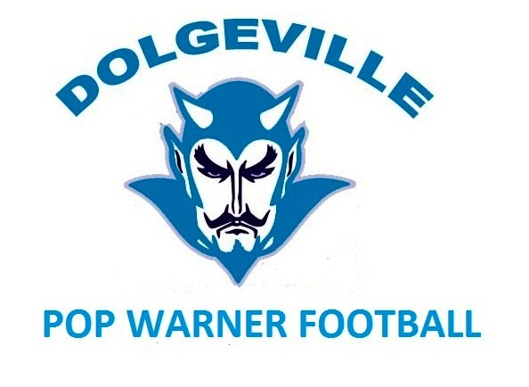

Social Media Policy

Use the guidelines & policies in this document, when you contribute and participate in any social media activity. Not only does it protect both you and Dolgeville Pop Warner, but also you can have confidence knowing you are representing Dolgeville Pop Warner in a responsible professional manner.
While Dolgeville Pop Warner respects your privacy, conduct that has or has the potential to have a negative effect on our organization may become subject to disciplinary action, up to expulsion from Dolgeville Pop Warner. Review the guidelines, take accountability, and remember good judgment. Social media are internet based tools for sharing and discussing information. These include but are not limited to Twitter, Facebook, YouTube, Blogs, wikis, message boards, micro blogs, and other community based sites or collaboration tools. This also includes any other sites where information
like text, images, video, sound, or other files can be uploaded or posted. As Dolgeville Pop Warner, we are accountable for how we talk about our business, whether it’s in person, on the phone, in print, or online. Before you post information online that relates in any way to Dolgeville Pop Warner start by being thoughtful about what you share and how you share it.

The six guidelines below explain our policies as they apply to social media:

1. Keep confidential information confidential. Any statement, whether made online or offline or
through images, videos or sound files, related to or referencing Dolgeville Pop Warner business, players, cheerleaders, teams, coaches, parents, or other volunteers, regardless of the media or forum used, must strictly comply with said policies and procedures. Keep any Internet based conversation about the Dolgeville Pop Warner focused on publicly known information. If you are not sure whether something is appropriate to post, double check what you’re thinking, and get a second opinion from the Board Members of Dolgeville Pop Warner. Contact information is located on the organization's website at http://dolgevillepopwarner.weebly.com/.

2. Be accurate, truthful and considerate in your posts. Be constructive, provide appropriate context,
and think about the impact of your comments. Words matter...And remember that anyone, including parents, student athletes or any volunteers can find and see postings. So be responsible about what you share and how you share it just as you would at work or at home.

3. Take responsibility for your words. Remember that individuals (i.e. parents, family members,
volunteers and student athletes) can be held personally accountable for comments deemed to be
defamatory, obscene, proprietary or libelous, whether they pertain to Dolgeville Pop Warner, or another person.
Personal attacks from parent to parent or student athletes and or family members will not be tolerated by
Dolgeville Pop Warner as indicated above.

4. Assume that anyone can see what you post. The internet is a fully search-able, which means that
anyone with an Internet connection including our student athletes can find even the most obscure
information.

5. Identify yourself. Use a personal email address, not a Dolgeville Pop Warner’s email address as your primary means of identification. Under no circumstances are you permitted to identify yourself as a spokesperson for Dolgeville Pop Warner.

6. Pass on any press inquiries. Social media postings occasionally generate media coverage. If you are
ever asked to make a comment regarding Dolgeville Pop Warner by media, you are to direct those individuals to
the Dolgeville Pop Warner website. There they may find the entire Executive Boards contact information.

7. Penalties for failure to comply with these policies include but are not limited to, banishment from practices, games, events, and or all Dolgeville Pop Warner function for one day or up to two years for repeat offenses. All punitive actions will be taken by a vote of the Dolgeville Pop Warner Executive Board.

Parent or Guardian Signature:

